## A

## Project Report

## on

Title of Project

Quiz Game System

Submitted in partial fulfillment of the requirements for the award of degree of

## Bachelor of (… )

(Times New Roman, Size16, Bold)

Submitted By:

Student Name1: Exam Seat no

Academic Year: 20… – 20…

Submitted to:

## Swami Ramanand Teerth Marathwada University, Nanded

(Times New Roman, Size16, Bold)



Royal Education Society’s

# College of Computer Science and Information Technology, Latur

(Times New Roman, Size18, Bold)

|  |  |  |
| --- | --- | --- |
| Guided By | (Size = 14, Times, Bold) | Head of Department |
| Name of Guide | (Size = 12, Times) | Name of HoD |

### Royal Education Society’s

COLLEGE OF COMPUTER SCIENCE AND INFORMATION TECHNOLOGY, LATUR.

CERTIFICATE

(Times New Roman, Size14)

This is to certify that the project entitled “<PROJECT TITLE>” has been carried out by

<Student Name1, Student Name2, Student Name3> under my guidance in partial fulfillment of the degree i.e. Bachelor of Computer Application of SRTMU, Nanded during the academic year 2015-2016. <Times New Roman, font size 14>

|  |  |  |
| --- | --- | --- |
| Guide | (Size = 14, Times, Bold) | Head of Department |
| Name of Guide | (Size = 12, Times) | Name of HoD |

# ACKNOWLEDGEMENT

<font size 18, Bold>

(Times New Roman, Size14)

First and foremost, we are grateful to Swami Ramanand Teerth Marathwada University, Nanded for giving an opportunity to deliver project.

We would like to convey our gratitude to Dr. N. S. Zulpe, Principal of College of Computer Science and Information Technology, Latur who gave us necessary information and guidance for project.

We would like to thank Project Guide <Name of project guide> who guided us through doing these projects, provided with invaluable advice, helped us in difficult periods and provided practical assistant for our project. His/Her willingness to motivate us contributed tremendously to the success of these projects.

We would like to express our special thanks of gratitude to our Head of the Department of Computer Application <Name of HOD> who helped us a lot in finalizing this project.

Besides we would like to thank all staff members who helped us by giving advice and providing equipment which we needed.

At last but not in least we would like to thank all who helped and motivated us.

### With Sincere Thanks,

1. Student Name
2. Student Name
3. Student Name

Index

|  |  |  |
| --- | --- | --- |
| Sr. No. | Topic Name | Page No. |
| 1 | Abstract |  |
| 2 | Introduction |  |
|  | 2.1 Project Overview |  |
|  | 2.5 Front End |  |
|  | 2.6 Back End |  |
| 3 | System Design |  |
|  | 3.2 E-R Diagram |  |
|  | 3.3 Data Flow Diagram (First Level) |  |
| 8 | References: |  |
|  | 8.1 Book(s) |  |
|  | 8.2 Website(s) |  |
|  |  |  |
|  |  |  |
|  |  |  |
|  |  |  |

* 1. **Introduction**

**Objective:**

The main objective of this 4 week project is to develop a client/server model, which deals with **“**Online Restaurant Meal Reservation System”. The system has two parts first for the customers and the other for the management side.

The customer side allows the customer to view menu list according to the time of delivery he desires and reserve meal for that specific time, and at the management side the staff is allowed to edit information regarding menu list, price, assigning cook, maintain information regarding the orders placed, etc.

Let’s concentrate on booking area in a restaurant. In traditional booking system, a customer has to make a phone call in order to get his meal reserved. If luckily the phone gets connected, then the customer does some formal conversation like hello, hi, etc. Than he demands for today’s menu and do some discussion over menu items then he orders and he has to give some of this identification specifications. This process takes 5-8 minutes to complete. On the receiver side there is hardly one phone line and one operator. So he can cover around 15-20 orders maximum in an hour.

|  |
| --- |
| 2.5 Front End : PHP , HTML, CSS, JavaScript |
| 2.6 Back End: MySQL |

**Minimum Hardware Requirements**  
(1) Processor: Intel Core I3 or above  
(2) RAM: 512 MB  
(3) Hard Disc: 20 GB

**Minimum Software Requirements**  
(1) Front End Tool: PHP  
(2) Back End Tool: MySQL  
(3) Development Tools: Adobe Dreamweaver, WAMP Server  
(4) Browser: Any browser

ER Diagram:

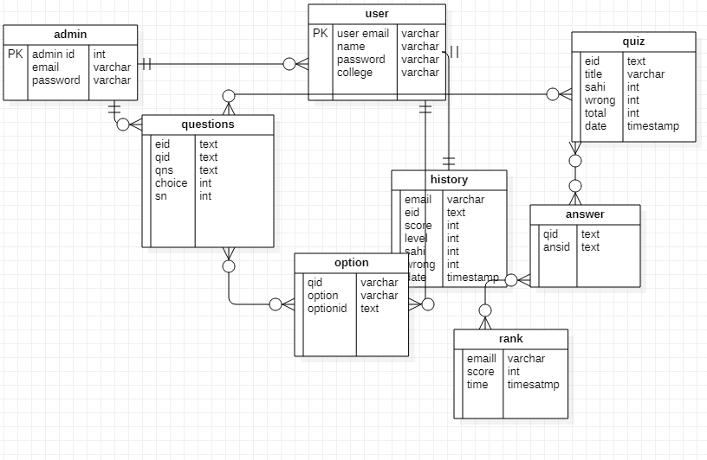

3.3 Data Flow Diagram (First Level)

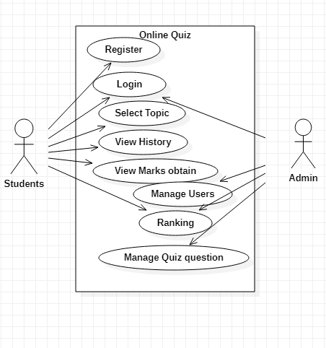

**Reference:**

**BOOK :**

1. [The Joy of PHP Programming](https://gbksoft.com/blog/most-popular-books-for-learning-php/#lmzNb)
2. [Learning PHP, MySQL, JavaScript, and CSS (5th edition)](https://gbksoft.com/blog/most-popular-books-for-learning-php/#CA3Ta)
3. [Murach’s PHP and MySQL (3rd edition)](https://gbksoft.com/blog/most-popular-books-for-learning-php/#EivKC)
4. [PHP and MySQL Web Development (5th edition)](https://gbksoft.com/blog/most-popular-books-for-learning-php/#xsDGS)
5. [PHP Cookbook (3rd edition)](https://gbksoft.com/blog/most-popular-books-for-learning-php/#cevCy)

**Website:**

1 ) <https://www.w3schools.com/php/>

2 ) https://www.w3schools.com/sql/default.asp

### 